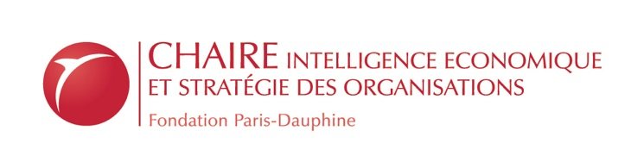

Strategic Issue Management Workshop
With Tomi Laamanen, editor-in-chief, Long Range Planning
October 15th, 2019
University Paris-Dauphine – PSL

The Chair “Strategic and Competitive Intelligence” at Université Paris-Dauphine organizes on October 15th 2019 a workshop on Strategic Issue Management.
We invite authors to submit their work to participate to a poster and paper development session with Tomi Laamanen, board member and treasurer of the Strategic Management Society, editor-in-chief of the Long Range Planning journal and editorial board member of many other journals. Authors selected for the poster session will participate to a “meet the editor” and paper development session with Tomi Laamanen and other editors from recognized scientific journals.

Strategic Issue Management workshop

The Strategic Issue Management workshop builds on the seminal paper by Ansoff (1980), that introduces the concept. A strategic issue is “a forthcoming development, either inside or outside of the organization, which is likely to have an important impact on the ability of the enterprise to meet its objectives” (Ansoff, 1980, p.4). As such, strategic issue management relates to the capability of the firm to monitor its environment, detect both weak and strong signals, learn, and adapt to changing circumstances (Laamanen et al., 2017; Ansoff, 1980). In this context, the individual capacity to detect and master sensitive information, as well as organizational systems and processes designed to collect, interpret and communicate strategic knowledge, support the performance of organizations (Dameron and Very, 2018).

Previous research highlighted two main approaches to strategic issue management: a cognitive approach, which focuses on “the cognitive underpinnings of organizational responses to external changes” (Laamanen et al., 2017, p.1); and a practice-oriented approach (Whittington et al., 2011), that highlights the activities of actors in the development of strategy.

The objective of this workshop is to advance our theoretical and managerial understanding of strategic issue management. We seek contributions that build on or substantially extend existing research streams on this theme. In particular, we invite submissions on the following topics (not exhaustive):
- Corporate foresight
- Strategic sensemaking
- Strategic uncertainty
- Strategic planning
- Environment monitoring
- Issue diagnosis
- Issue selling
- Attention-based view
- Sensing and seizing of opportunities
- Scenario based strategizing, strategic foresight
- Open strategizing
References
Ansoff, H. I. (1980). Strategic issue management. Strategic management journal, 1(2), 131-148.
Dameron, S., & Very, P. (2018). Stratégie, information et diplomaties stratégiques: convergences et enjeux. Finance contrôle stratégie, (NS-3).
Laamanen, T., Maula, M., Kajanto, M., & Kunnas, P. (2017). The role of cognitive load in effective strategic issue management. Long Range Planning, 30, 1-15.
Whittington R., Cailluet L. et Yakis-Douglas B. (2011), « Opening Strategy : Evolution of a Precarious Profession ». British Journal of Management, 22 (3), p. 531-544.

Submission Process and Deadlines

We invite research projects that are in-progress. Posters often present preliminary results from pilot data. Since poster submissions reflect research that is still in progress, the extended abstracts will be editorially reviewed rather than going through a full peer review process. Both an extended abstract (Microsoft Word format) and a poster (PDF format) must be submitted for a poster to be considered.

Extended Abstract
- 2,000 words (or less)
- State the research question(s) clearly
- Since posters are generally in-progress research pieces, define the status of the research. E.g., have data been collected?
- Key references to support the research
- Figures, tables, and appendices as needed
- PDF Format
Poster
- A complete draft of the poster
- Create a single PowerPoint slide (Size A1: 841 mm x 594 mm)
- PPT, PPTX or PDF format
The deadline for submissions is 22nd of September 2019.
Manuscripts should be submitted by e-mail at chaire.ieso@fondation-dauphine.fr
Fees and logistics

Participation is free but we can welcome a limited number of participants
The workshop will hold at Université Paris-Dauphine – PSL, Place du Maréchal de Lattre de Tassigny, 75016, Paris, France
For any question regarding academic elements, administrative and logistical elements, please contact chaire.ieso@fondation-dauphine.fr with “workshop SIM” in the object of the email.

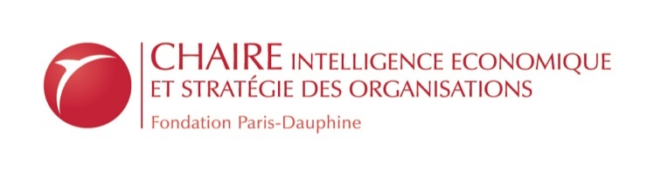
http://chaireieso.fondation.dauphine.fr

